

**LAB EXERCISE 8**

**Implementation of Memory Management Algorithms**

**Submission Date:23-05-2022**

Name: Jayannthan P T

Dept: CSE ‘A’

Roll No.: 205001049

1. Free space is maintained as a linked list of nodes with each node having the starting byte address and the ending byte address of a free block. Each memory request consists of the process-id and the amount of storage space required in bytes. Allocated memory space is again maintained as a linked list of nodes with each node having the process id, starting byte address and the ending byte address of the allocated space. When a process finishes (taken as input), the appropriate node from the allocated list should be deleted and this free disk space should be added to the free space list. [Care should be taken to merge contiguous free blocks into one single block. This results in deleting more than one node from the free space list and changing the start and end address in the appropriate node]. For allocation use first fit, worst fit and best fit algorithms..

**Algorithm:**

1. We create a header file which defines the structure with components as start, end, sixe, status, id, next pointer to the node.
2. It also has a functions insertlast(), insertmiddle(), create new node() and sorted merging()
3. We create an instance of the structure in main function
4. Read the number of partitions of the memory from the usetr
5. Read the starting and ending points of each partitions
6. For each entry create new node and insertlast
7. Display the status after memory partitioning
8. Each hole is allotted a unique id by itself and is not changed until the program is ended
9. Inside the do while loop:
   * Ask the user to choose the algorithm
   * Have a 2D array where we store the choice of algorithm
   * Inside it we have another do while loop where we ask for entry/allocate, exit/deallocate, display, coalesce and exit
   * ALLOCATION:

Ask the user for the size of process

* + 1. First fit:
       1. Check which is the first hole that satisfies the given process’s size and return the position of that node
    2. Best fit:
       1. Assumes min as a constant
       2. Iterates through the list to find the min difference between process size and node size
       3. If min value has changed the node pointed by the function is allocated for the process
    3. Worst fit:
       1. Assumes 0 as max value
       2. Iterates through the list to find the max difference
       3. If max value is changed allocate the process to the node pointed by the function

allocate()

If ptrsize is equal to the node size we allocate the nide as it is

If ptrsize is greater than the process size we insert 2 node one with size equal to process size and other with size as difference between the pointed node

* + DEALLOCATION:
    1. We search the pid in the list and find the node in which the process is allocated.
    2. Change the status of the node to ‘H’ and delete the process
    3. It also the combine function which combines the holes with same id to bring back the initial state
  + DISPLAY:
    1. Displays the list with free spaces and the other list with accommodation of processes
  + COALESCING:
    1. It combines all the adjacent partitions with status ‘H’ irrespective of the hole id

**Code:**

#include <stdio.h>

#include <stdlib.h>

#include <string.h>

#include <limits.h>

**struct** node

{

**int** start;

**int** end;

**int** size;

**char** status[3];

**struct** node *next;

};

**struct** node *newNode(**int** start, **int** end);

**int** insert(**struct** node *temp, **struct** node **head);

**struct** node *insertEnd(**struct** node *, **struct** node *);

**struct** node *clone(**struct** node *list);

**struct** node *merge(**struct** node *h1, **struct** node *h2);

**struct** node *newNode(**int** start, **int** end)

{

**struct** node *temp = (**struct** node *)malloc(sizeof(**struct** node));

    strcpy(temp->status, "H");

    temp->end = end;

    temp->start = start;

    temp->size = temp->end - temp->start;

    temp->next = NULL;

    return temp;

}

**struct** node *insertEnd(**struct** node *p, **struct** node *temp)

{

**struct** node *ptr = p;

    if (!ptr)

    {

        p = temp;

        p->next = NULL;

    }

    else

    {

        while (ptr->next)

            ptr = ptr->next;

        ptr->next = temp;

        temp->next = NULL;

    }

    return p;

}

**int** insert(**struct** node *temp, **struct** node **head)

{

    if (!temp)

        return 0;

**struct** node *ptr = *head;

    if (!*head)

    {

        *head = insertEnd(*head, temp);

        return 1;

    }

    if (temp->start < ptr->start)

    {

        temp->next = *head;

        *head = temp;

        return 1;

    }

    while (ptr->next && temp->start > ptr->next->start)

        ptr = ptr->next;

    temp->next = ptr->next;

    ptr->next = temp;

    return 1;

}

**struct** node *clone(**struct** node *list)

{

    if (!list)

        return NULL;

**struct** node *result = (**struct** node *)malloc(sizeof(**struct** node));

    result->start = list->start;

    result->end = list->end;

    result->size = list->size;

    strcpy(result->status, list->status);

    result->next = clone(list->next);

    return result;

}

**struct** node *merge(**struct** node *h1, **struct** node *h2)

{

    if (!h1)

        return h2;

    if (!h2)

        return h1;

    if (h1->start < h2->start)

    {

        h1->next = merge(h1->next, h2);

        return h1;

    }

    else

    {

        h2->next = merge(h1, h2->next);

        return h2;

    }

}

**void** combine(**struct** node **p)

{

**struct** node *ptr = *p, *temp;

    while (ptr)

    {

        temp = ptr;

        while (temp->next && temp->end == temp->next->start)

            temp = temp->next;

        ptr->next = temp->next;

        ptr->end = temp->end;

        ptr = ptr->next;

    }

}

**struct** node *deallocate(**struct** node **p, **char** *pid)

{

**struct** node *ptr = *p, *prev;

    if (ptr && strcmp(ptr->status, pid) == 0)

    {

        *p = ptr->next;

        strcpy(ptr->status, "H");

        return ptr;

    }

    while (ptr && strcmp(ptr->status, pid))

    {

        prev = ptr;

        ptr = ptr->next;

    }

    if (!ptr)

        return NULL;

    strcpy(ptr->status, "H");

    prev->next = ptr->next;

    return ptr;

}

**void** table(**struct** node *p, **char** str**[]**)

{

**struct** node *ptr = p;

    if (!ptr)

    {

        printf("NULL\n\n");

        return;

    }

    for (**int** i = 0; i < strlen(str); i++)

        printf("%c", str[i] == '|' ? '+' : str[i] == '-' ? ' '

                                                         : '-');

    printf("\n%s\n", str);

    for (**int** i = 0; i < strlen(str); i++)

        printf("%c", str[i] == '|' ? '+' : str[i] == '-' ? ' '

                                                         : '-');

    printf("\n");

**int** end, s;

    end = ptr->end;

    s = strlen(ptr->status);

    while (ptr)

    {

        if (!ptr->next || ptr->end == ptr->next->start)

            printf("%-*d", 9 + strlen(ptr->status), ptr->start);

        else

            printf("%-*d%-*d", 9 + strlen(ptr->status), ptr->start, 9, ptr->end);

        end = ptr->end;

        s = strlen(ptr->status);

        ptr = ptr->next;

    }

    printf("%d", end);

    printf("\n\n\n");

}

**void** disp(**struct** node *p)

{

**char** buf[100], mem[1000];

**struct** node *ptr = p;

    strcpy(mem, "|");

    while (ptr)

    {

        if (!ptr->next || ptr->end == ptr->next->start)

            sprintf(buf, "    %s    |", ptr->status);

        else if (ptr->end != ptr->next->start)

            sprintf(buf, "    %s    |---------|", ptr->status);

        strcat(mem, buf);

        ptr = ptr->next;

    }

    table(p, mem);

}

**void** display(**struct** node *p, **struct** node *q)

{

    printf("\nAllocated Memory Space\n\n");

    disp(p);

    printf("Free Memory Space\n\n");

    disp(q);

**struct** node *r = merge(clone(p), clone(q));

    printf("Physical Memory Space\n\n");

    disp(r);

    free(r);

}

**int** first(**struct** node *f, **int** size)

{

**struct** node *ptr = f;

    while (ptr && !(ptr->size >= size))

    {

        ptr = ptr->next;

    }

    if (!ptr)

        return -1;

    return ptr->size;

}

**int** best(**struct** node *f, **int** size)

{

**struct** node *ptr = f;

**int** min = INT_MAX;

    while (ptr)

    {

        if (ptr->size - size > 0 && min > ptr->size - size)

            min = ptr->size - size;

        ptr = ptr->next;

    }

    if (min == INT_MAX)

        return -1;

    return min + size;

}

**int** worst(**struct** node *f, **int** size)

{

**struct** node *ptr = f;

**int** max = INT_MIN;

    while (ptr)

    {

        if (ptr->size - size > 0 && max < ptr->size - size)

            max = ptr->size - size;

        ptr = ptr->next;

    }

    if (max == INT_MIN)

        return -1;

    return max + size;

}

**int** whichfit(**struct** node *f, **int** size, **int** ch)

{

    if (ch == 1)

        return first(f, size);

    if (ch == 2)

        return best(f, size);

    if (ch == 3)

        return worst(f, size);

}

**struct** node *allocate(**struct** node **f, **char** *pid, **int** size, **int** ptrsize)

{

    if (ptrsize - size < 0)

        return NULL;

**struct** node *ptr = *f, *prev;

    if (ptr->size == ptrsize)

    {

        if (ptr && ptr->size >= size)

        {

            if (ptr->size == size)

            {

                *f = ptr->next;

                strcpy(ptr->status, pid);

                return ptr;

            }

            else

            {

**struct** node *temp1 = newNode(ptr->start, ptr->start + size);

**struct** node *temp2 = newNode(ptr->start + size, ptr->end);

                *f = temp2;

                temp2->next = ptr->next;

                strcpy(temp1->status, pid);

                free(ptr);

                return temp1;

            }

        }

    }

    while (ptr && !(ptr->size == ptrsize))

    {

        prev = ptr;

        ptr = ptr->next;

    }

    if (!ptr)

        return NULL;

    if (ptr->size == size)

    {

        prev->next = ptr->next;

        strcpy(ptr->status, pid);

        return ptr;

    }

    else

    {

**struct** node *temp1 = newNode(ptr->start, ptr->start + size);

**struct** node *temp2 = newNode(ptr->start + size, ptr->end);

        prev->next = temp2;

        temp2->next = ptr->next;

        strcpy(temp1->status, pid);

        free(ptr);

        return temp1;

    }

}

**int** main()

{

**int** ch, n, start, end;

    printf("\nEnter the Memory Representation:");

    printf("\nEnter the no.of partitions in memory: ");

    scanf("%d", &n);

**struct** node *mempool = NULL, *alloc = NULL, *temp = NULL;

    for (**int** i = 0; i < n; i++)

    {

        printf("Enter Starting and ending address of partition %d: ", i + 1);

        scanf("%d%d", &start, &end);

        if (start >= end || i && temp->end != start)

        {

            i--;

            printf("Invalid entry,enter again\n");

        }

        else

        {

            temp = newNode(start, end);

            mempool = insertEnd(mempool, temp);

        }

    }

    display(alloc, mempool);

    do

    {

        printf("\n1. First Fit\n2. Best Fit \n3. Worst Fit \n4. Exit \nEnter your choice: ");

        scanf("%d", &ch);

        switch (ch)

        {

        case 1:

        case 2:

        case 3:

            break;

        case 4:

            printf("Exiting...\n");

            return 0;

            break;

        default:

            printf("\nInvalid Input!\n");

        }

**int** ch1, size;

**char** pid[3];

**char** fits[3][15] = {"First Fit", "Best Fit", "Worst Fit"};

        do

        {

            printf("\n\t\t%s Memory Allocation Algorithm\n\n1. Entry / Allocate\n2. Exit / Deallocate \n3. Display \n4. Coalescing of Holes \n5. Back to Algorithm \n6. Exit\nEnter your choice: ", fits[ch - 1]);

            scanf("%d", &ch1);

            switch (ch1)

            {

            case 1:

                printf("\nEnter process id : ");

                scanf("%s", pid);

                printf("Enter size needed : ");

                scanf("%d", &size);

                if (size <= 0)

                {

                    printf("\nInvalid size!\n");

                    break;

                }

                if (!insert(allocate(&mempool, pid, size, whichfit(mempool, size, ch)), &alloc))

                {

                    printf("\nCouldn't allocate memory to %s!\n", pid);

                    break;

                }

                else

                    printf("\nMemory is allocted to %s\n", pid);

                display(alloc, mempool);

                break;

            case 2:

                printf("\nEnter process id : ");

                scanf("%s", pid);

                if (!insert(deallocate(&alloc, pid), &mempool))

                {

                    printf("\nProcess %s is not there!\n", pid);

                    break;

                }

                else

                    printf("\n%s's memory is deallocted\n", pid);

                display(alloc, mempool);

                break;

            case 3:

                display(alloc, mempool);

                break;

            case 4:

                combine(&mempool);

                display(alloc, mempool);

                break;

            case 5:

                break;

            case 6:

                printf("Exiting...\n");

                return 0;

                break;

            default:

                printf("\nInavlid Input!\n");

            }

        } while (!(ch1 == 5 || ch1 == 6));

    } while (ch != 4);

    return 0;

}

**Output:**

1. 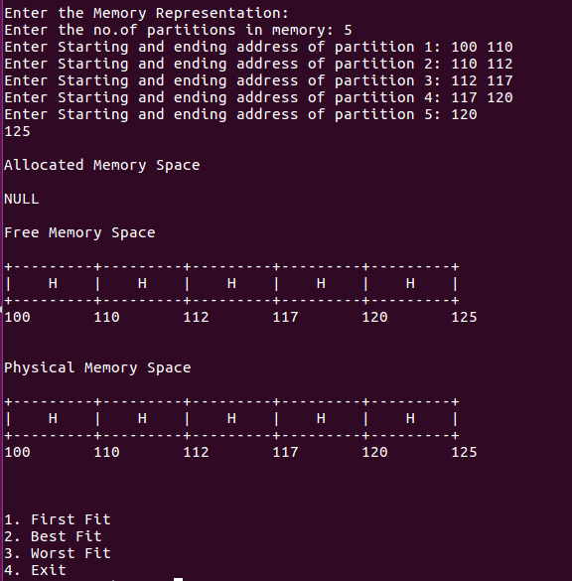

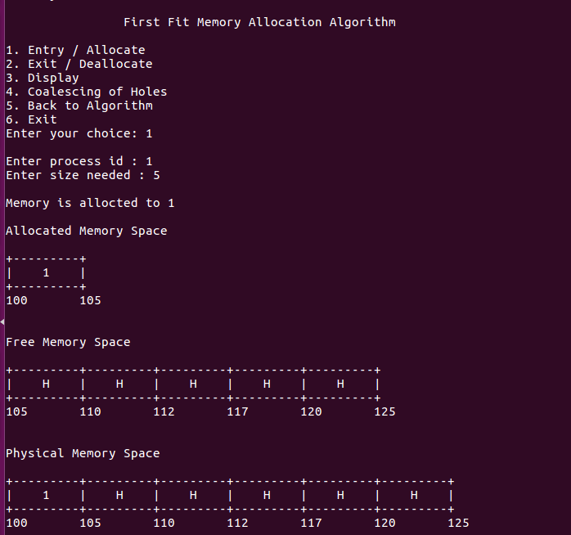

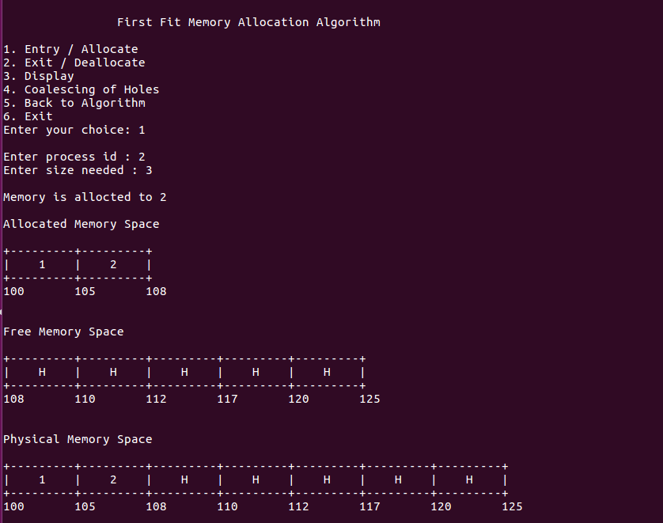

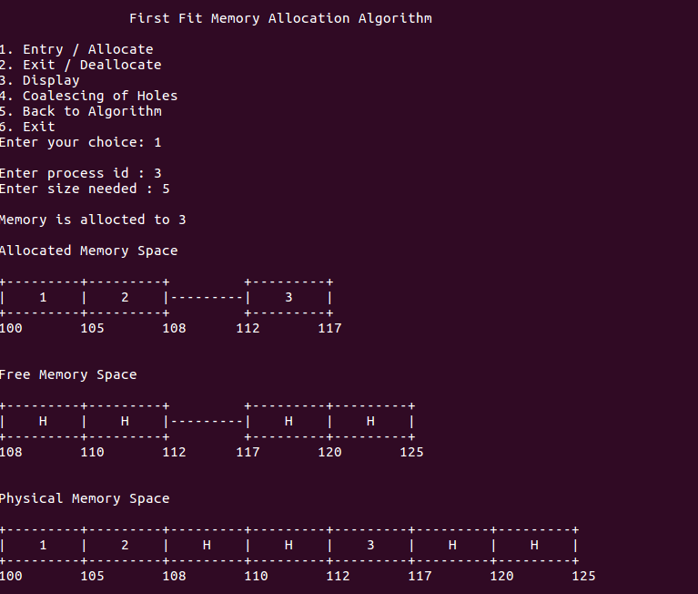

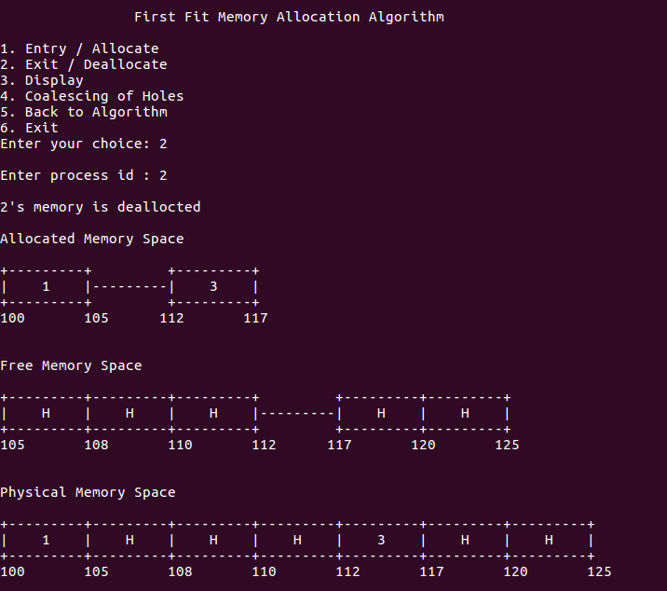

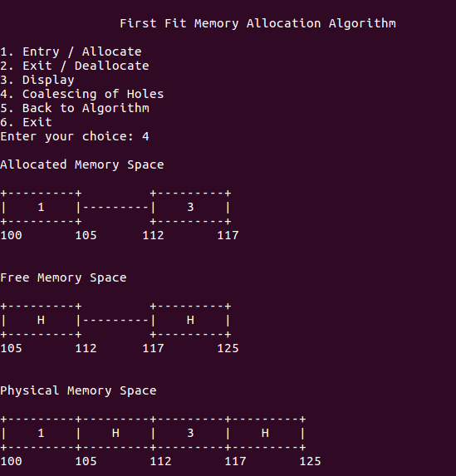

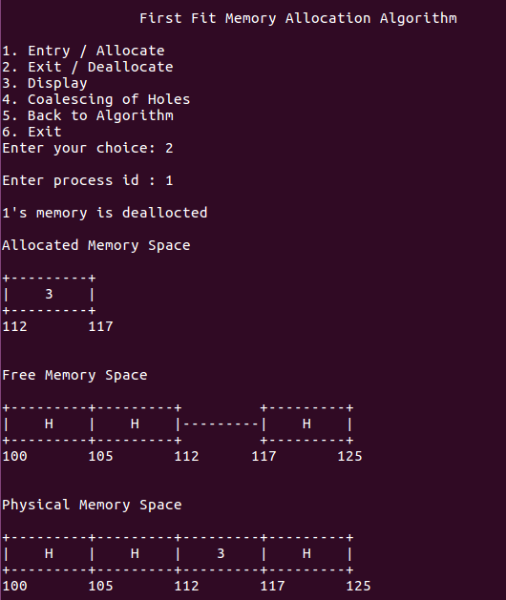

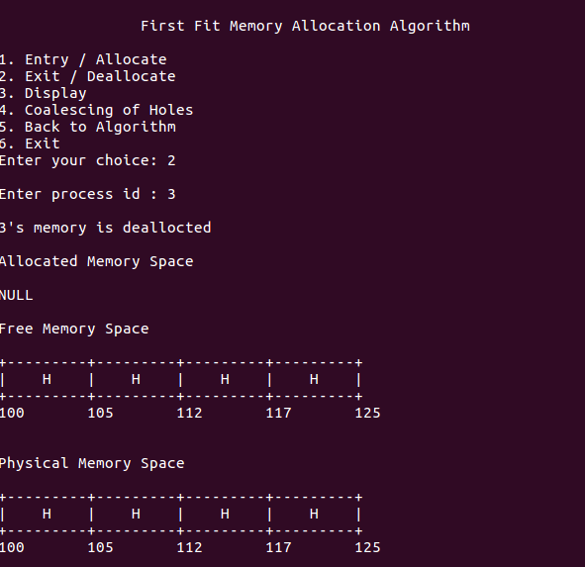

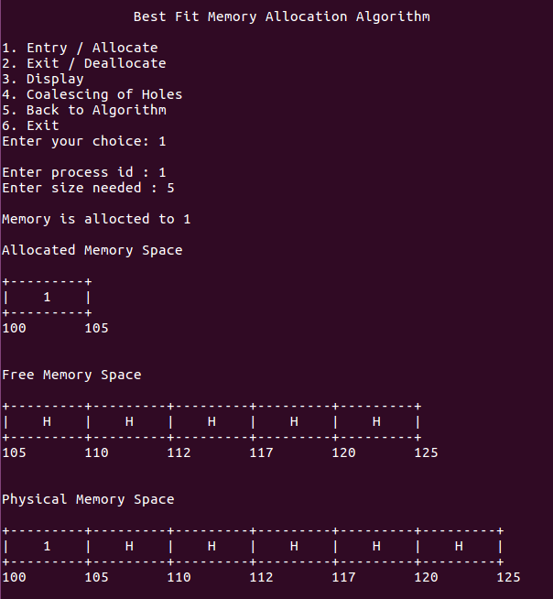

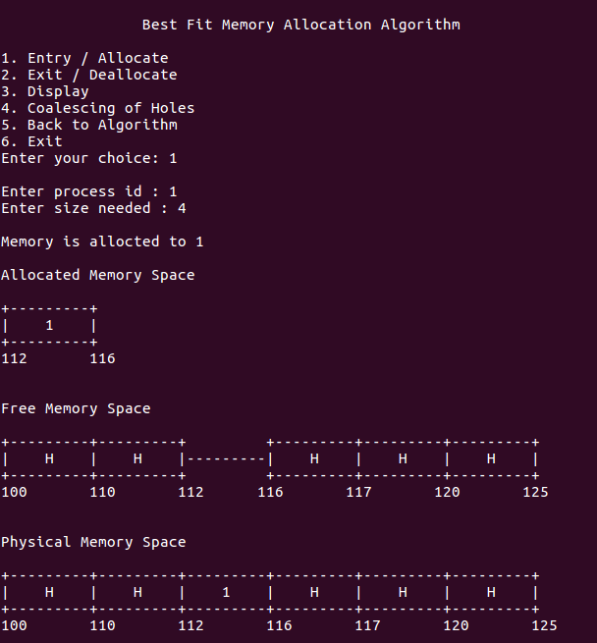

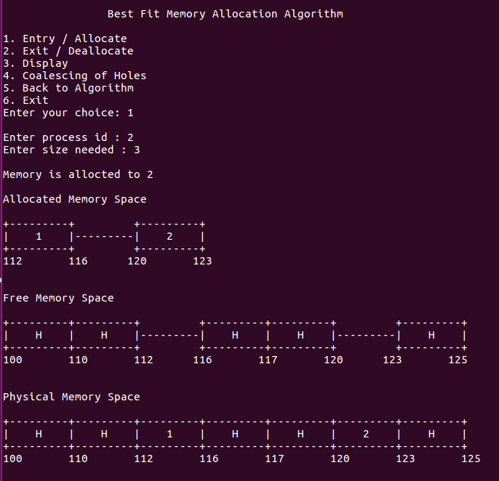

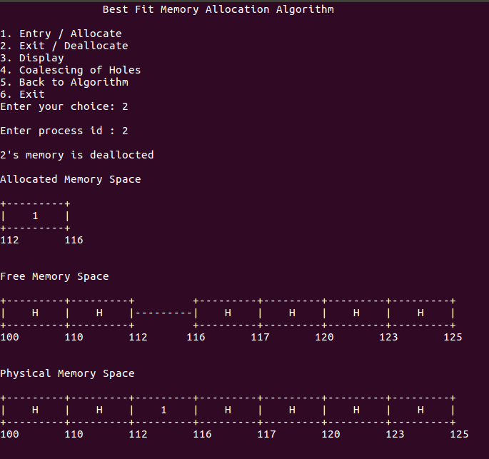

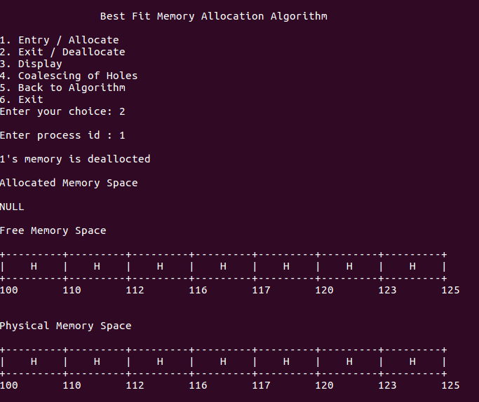

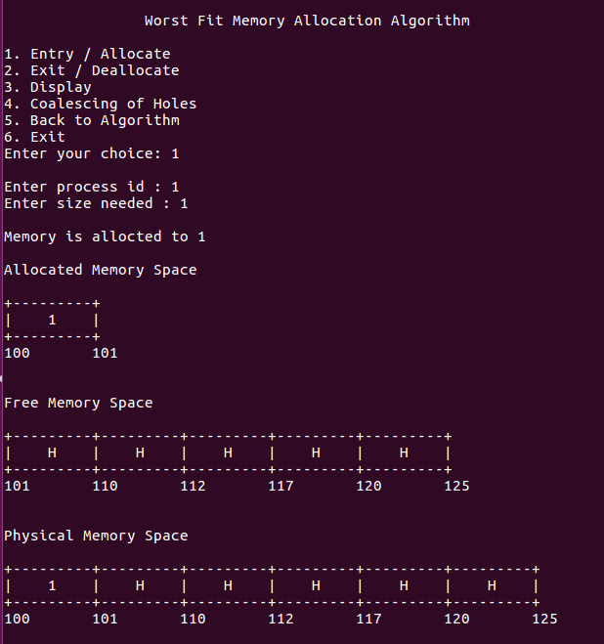

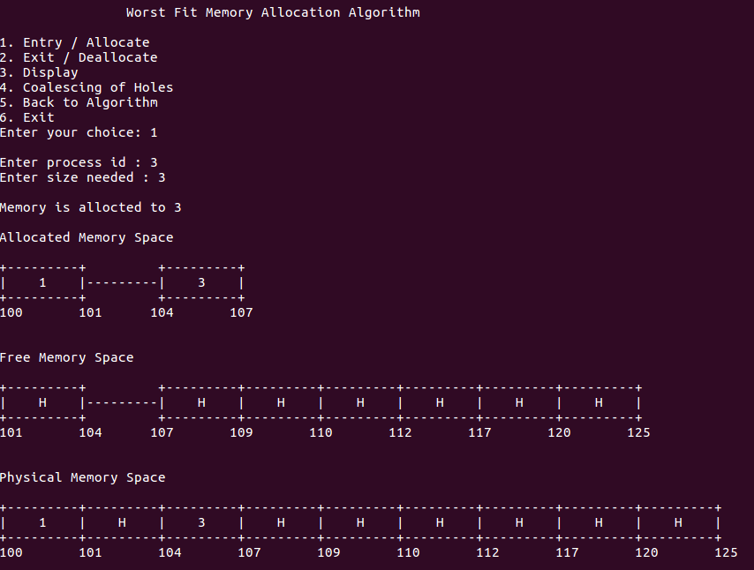

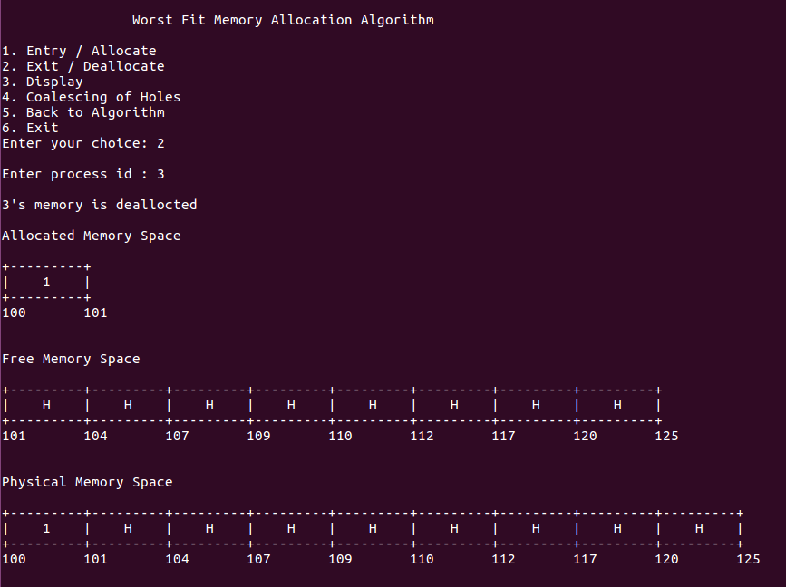

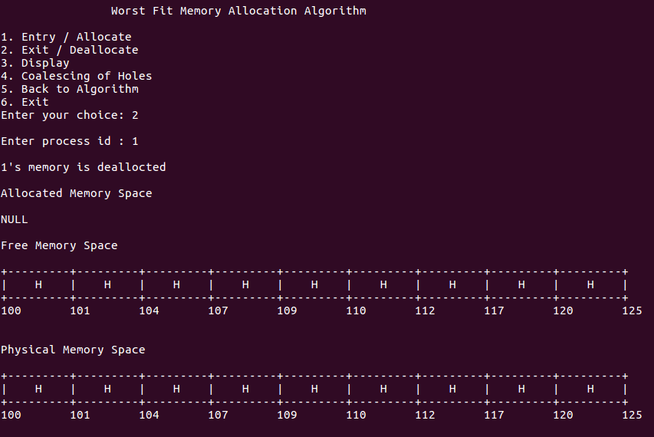

**Learning Outcome:**

* Learnt how to allocate memory for processes
* Learnt to manipulate memory and linked lists